**Project Design Phase-I** - **Solution Fit Template Project**

**Title:** Real-Time Communication System Powered by AI for Specially Abled **Team ID:** PNT2022TMID03512

**Explore AS, differentiate**

**Deﬁne CS, ﬁt into CC**

**AS**

**5. AVAILABLE SOLUTIONS**

The available solution is using sign language which takes time and hard to learn for the normal people.

Initially they could face issues in availability of the models as well as the cost could be an issue which can be solved after industries pick up the model and make it available

**CC**

**6. CUSTOMER CONSTRAINTS**

**CS**

**1. CUSTOMER SEGMENT(S)**

The target customers are the people who have problem in communicating with others

**Explore AS, differentiate**

**Define CS, fit into CC**

**BE**

**7. BEHAVIOUR**

People usually get the help of the translators to communicate with normal people.

In this project, it could be done by capturing the sign language using mobile.

**RC**

**9. PROBLEM ROOT CAUSE**

The root cause is the by birth defect that people could face in communication which makes them opt for sign language that makes the communication harder

**J&P**

**2. JOBS-TO-BE-DONE / PROBLEMS**

The problem which the people could face is inefficient communication with normal people which could make their life hard.

**Focus on J&P, tap into BE, understand RC**

|  |  |  |  |  |
| --- | --- | --- | --- | --- |
| **Identify strong TR & EM** | **3. TRIGGERS TR**  The people could get an idea when they get an exposure about the model in public places and also from work place. | **10. YOUR SOLUTION SL**  Capturing and storing the sign language pictures and using AI algorithm to convert them into text format or audio form to make the communication easier. | 1. **CHANNELS of BEHAVIOUR CH**     1. **ONLINE**   People could refer online videos to get an idea about the usage   * 1. **OFFLINE**   The people could get the knowledge about the resource by having an interaction with the people who have knowledge in this. |  |
| **4. EMOTIONS: BEFORE / AFTER EM**  People will face inferiority issues which leads to inefficient performance. But after using proper communication system they will overcome the inferiority and shine in their life. |

**Focus on J&P, tap into BE, understand RC**

**Focus on J&P, tap into BE, understand RC**

**Focus on J&P, tap into BE, understand RC**

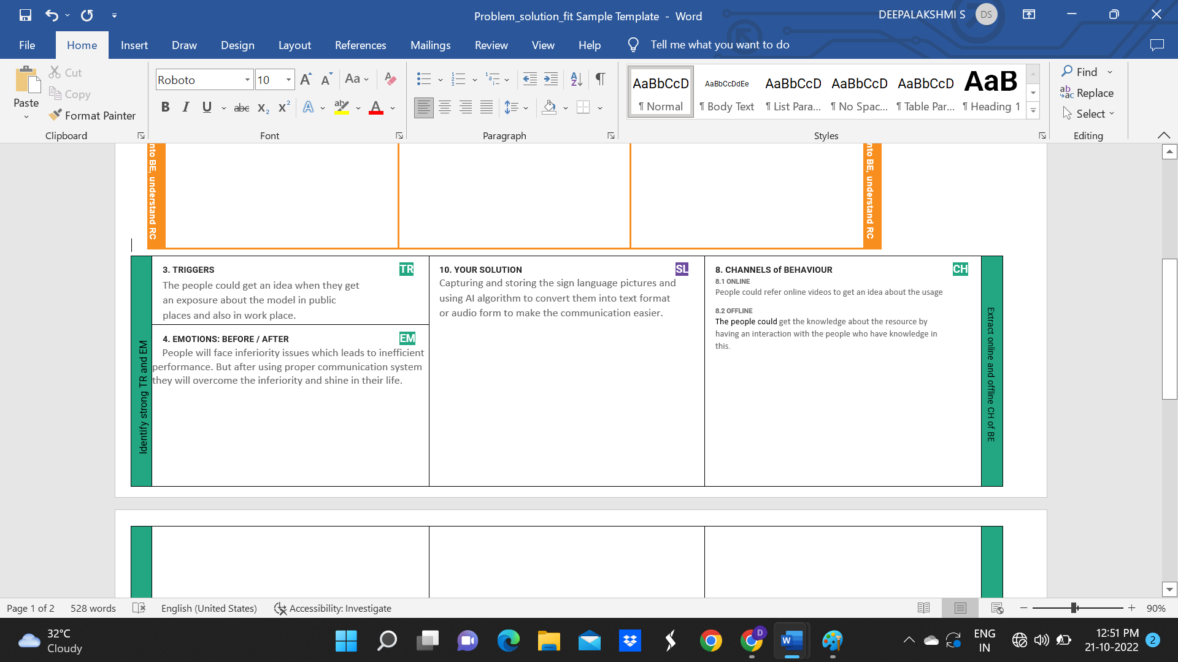

**Identify strong TR & EM**

**Identify strong TR & EM**